Assignment 5

Role of Digital, Analog, and PWM Pins in Arduino for Sensing, Decision-Making, and Control

1. Introduction
The Arduino UNO R3 is widely used in embedded and IoT systems because it allows interaction with the real world through its Digital Pins, Analog Pins, and PWM-enabled Pins.
These three types of pins work together to perform three essential functions:
- Sensing (collecting data from environment)
- Decision-making (processing data using logic/programs)
- Control (acting on devices like motors, LEDs, etc.)
This combination makes Arduino a complete system for real-world applications.

2. Digital Pins: Discrete Input and Output (Sensing & Control)
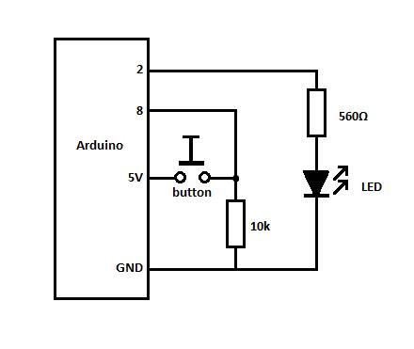
Explanation
Digital pins operate in two states:
- HIGH (1) → 5V
- LOW (0) → 0V
They are used for simple ON/OFF operations.
Role in Sensing
- Read signals from:
  - Buttons
  - Switches
  - Digital sensors (e.g., motion sensor)
Role in Control
- Control devices like:
  - LEDs (ON/OFF)
  - Relays
  - Buzzers
Key Points
- Fast and simple operation
- Ideal for binary decisions
- Used in logic-based systems
Digital pins form the basic interface between Arduino and external devices.

3. Analog Pins: Continuous Data Input (Sensing)
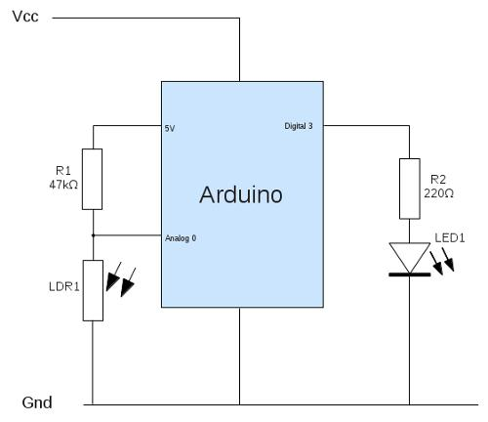
Explanation
Analog pins (A0–A5) read continuous voltage values (0–5V) and convert them into digital values using an ADC (Analog-to-Digital Converter).
Role in Sensing
- Used with sensors like:
  - Temperature sensors
  - Light sensors (LDR)
  - Gas sensors
Working
- Converts analog signals into values (0–1023)
- Helps Arduino understand real-world variations
Key Points
- High sensitivity to environmental changes
- Enables accurate data collection
- Essential for smart IoT systems
- Analog pins enable real-world data acquisition.

4. PWM Pins: Analog-like Output (Control)
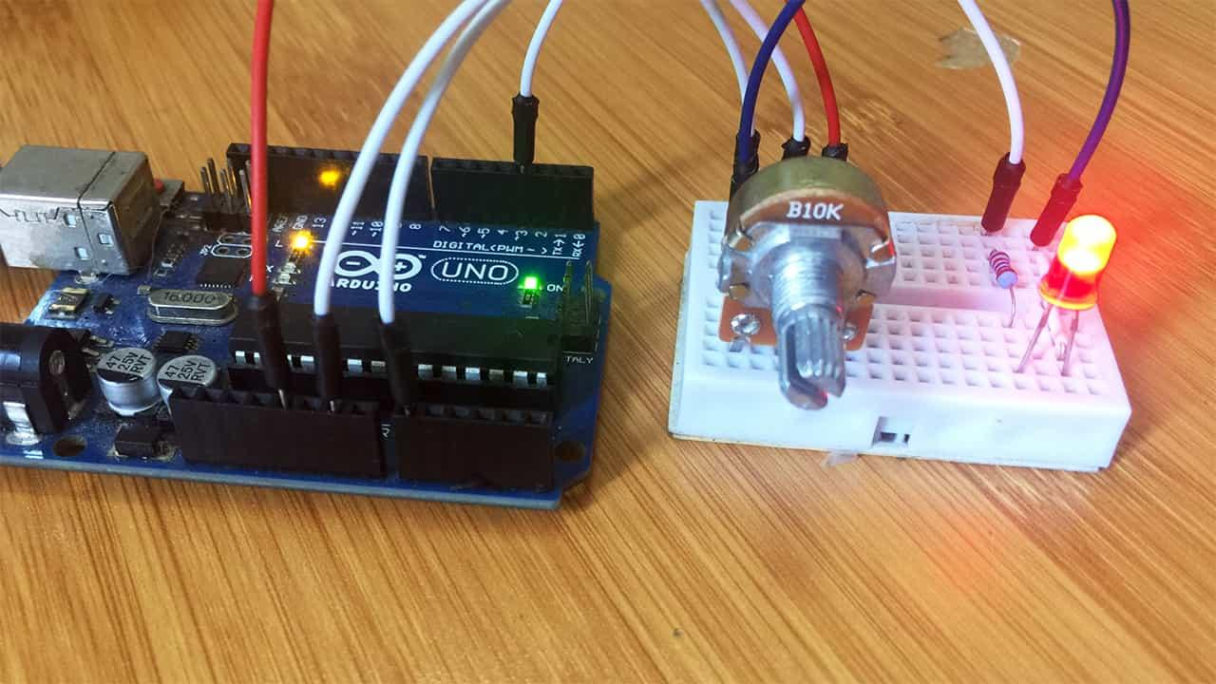
Explanation
PWM (Pulse Width Modulation) pins simulate analog output by varying the duty cycle of digital signals.
PWM Pins in Arduino
- Pins: 3, 5, 6, 9, 10, 11
Role in Control
- Control:
  - LED brightness
  - Motor speed
  - Fan speed
Working
- Rapidly switches ON/OFF
- Adjusts average voltage output
Key Points
- Provides smooth control
- Energy efficient
- Acts like analog output without DAC
PWM pins enable precise control over actuators.

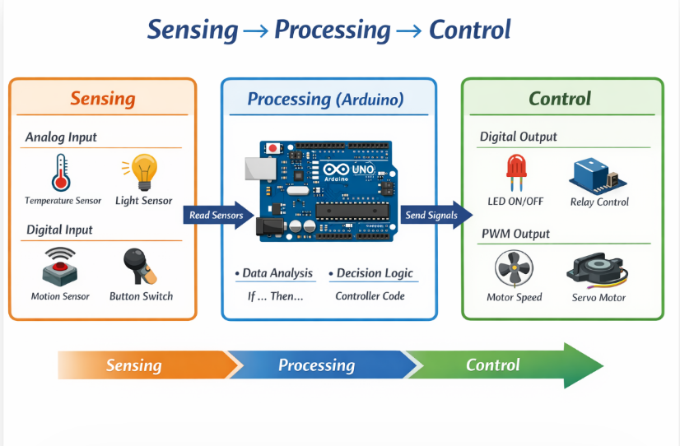
5. Integration: Sensing → Decision → Control

The real power of Arduino comes from combining all three types of pins.
Step-by-Step Process
- Sensing (Input Stage)
  - Analog pins read sensor data
  - Digital pins read ON/OFF inputs
- Decision-Making (Processing Stage)
  - Microcontroller processes input data
  - Executes logic using programmed conditions
- Control (Output Stage)
  - Digital pins control ON/OFF devices
  - PWM pins control variable devices

Example (Smart Fan System)
- Analog pin reads temperature sensor
- Arduino processes temperature value
- PWM pin adjusts fan speed
- Digital pin turns fan ON/OFF
This shows how all pins work together in an IoT system.

6. Role in IoT Systems
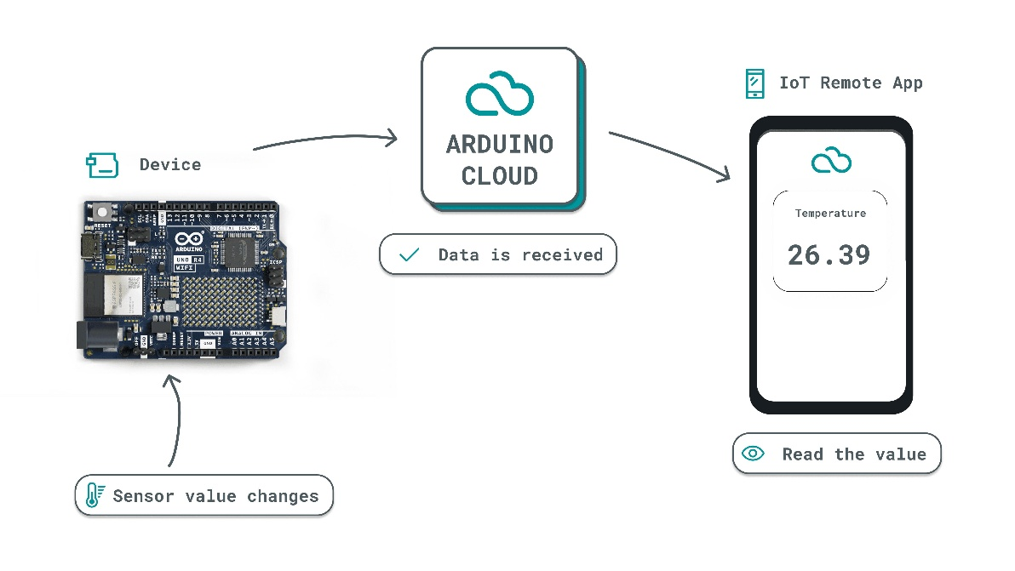
In IoT applications, Arduino acts as an edge device.
Functions
- Collects sensor data (Analog/Digital pins)
- Processes data locally
- Controls actuators (Digital/PWM pins)
- Sends data to cloud via communication protocols

7. Communication Support (UART)
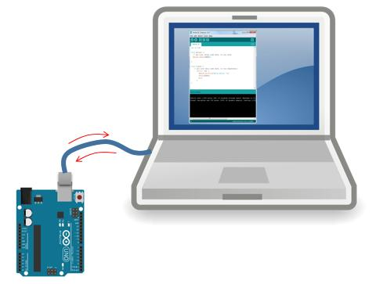
Arduino also supports communication using UART (Universal Asynchronous Receiver-Trnsmitter).
Key Points
- Uses:
  - TX (Transmit) pin
  - RX (Receive) pin
- Enables:
  - Communication with computers
  - Communication with IoT modules (Wi-Fi, Bluetooth)
UART helps Arduino share data with external systems and cloud platforms.

8. Analytical Summary
Comparison of Pin Types
Feature | Digital Pins | Analog Pins | PWM Pins
Type of Signal | Binary (0/1) | Continuous | Pulse-based (variable)
Main Function | Input/Output | Sensing | Control
Example Use | LED ON/OFF | Temperature sensor | Motor speed control

9. Conclusion
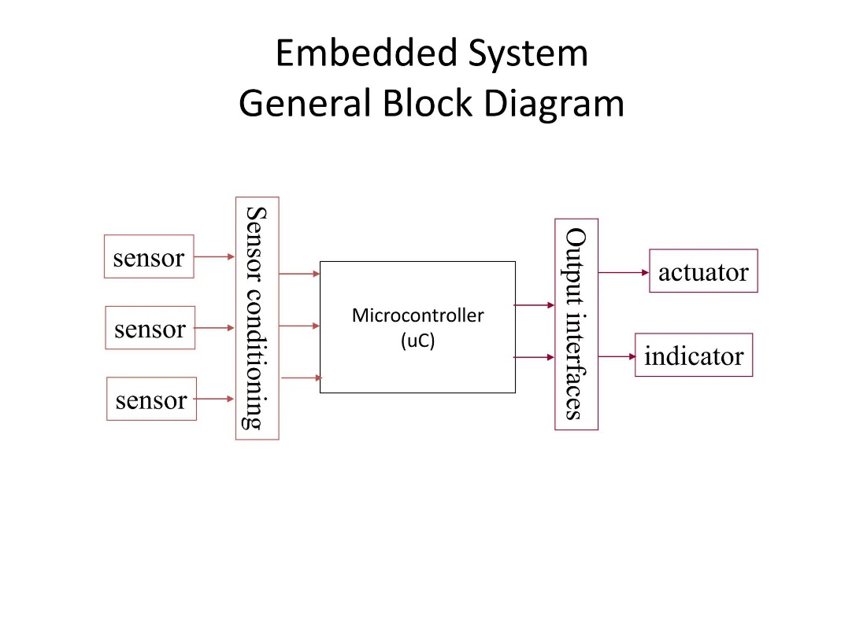
The Arduino UNO R3 effectively interacts with the real world using Digital, Analog, and PWM pins. Together, these pins support:
- Sensing through analog and digital inputs
- Decision-making through microcontroller logic
- Control through digital and PWM outputs
- Digital pins → simple ON/OFF interaction
- Analog pins → real-world data sensing
- PWM pins → smooth and precise control
- Combined → complete embedded and IoT system

